**Project Initialization and Planning Phase**

| Date | 09 July 2024 |
| --- | --- |
| Team ID | SWTID1720013031 |
| Project Name | Prediction and Analysis of Liver Patient Data Using Machine Learning |
| Maximum Marks | 3 Marks |

**Define Problem Statements (Customer Problem Statement Template):**

Accurate diagnosis and prognosis of liver disease are critical for effective patient management and treatment. Current diagnostic methods often lack precision and consistency, leading to delays and potential errors in identifying liver conditions. These inaccuracies can result in suboptimal treatment plans, negatively affecting patient outcomes and quality of life. By leveraging advanced machine learning techniques, we aim to enhance the accuracy and reliability of liver disease diagnostics. This improvement will enable healthcare providers to develop more effective, personalized treatment plans, ultimately improving patient outcomes and optimizing the use of medical resources.

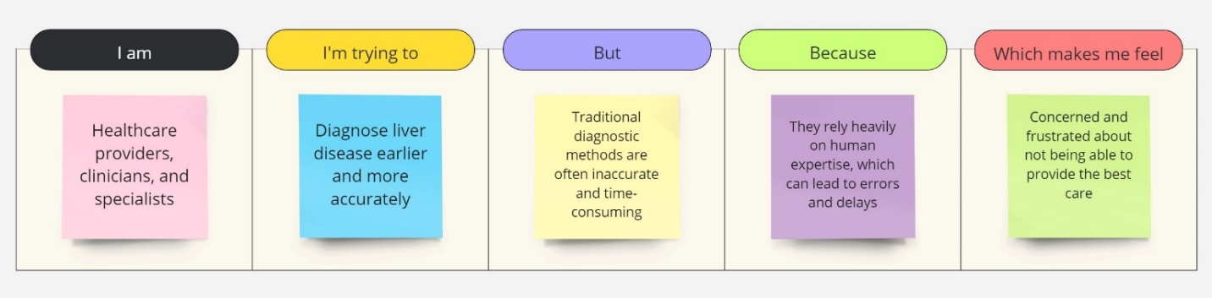

|  |  |  |  |  |  |
| --- | --- | --- | --- | --- | --- |
| **Problem**  **Statement (PS)** | **I am**  **(Customer)** | **I’m trying to** | **But** | **Because** | **Which makes me feel** |
| PS-1 | Healthcare providers, clinicians, and specialists | Diagnose liver disease earlier and more accurately | Traditional diagnostic methods are often inaccurate and time-consuming | They rely heavily on human expertise, which can lead to errors and delays | Concerned and frustrated about not being able to provide the best care |